

|  |  |
| --- | --- |
| Program Number | **1** |
| Roll Number | **1563** |
| Title of program | **Intrduction to UI and UI Lifecyle** |
| Objective | **Submit a PDF of your notes covering the following topics:**  **1) Introduction to UXD and UID**  **2) Elements of UID**  **3) Types of UI**  **4) UI Lifecycle** |

**User Interface**

A user interface is the point of human- computer interaction and communication on a device, webpage, or application. Every app and every website has a user interface.

User interface (UI) is a series of pages, screens, buttons, forms, and other visual elements that are used to interact with the device.



**User interface design**

User interface Design is the process of designing what a user interacts with when communicating with software.

User interface(UI) Design is the creation of graphics, illustrations and the used of photographic artwork and typography to enhance the display and layout a digital product within its various device views.

***Elements of UID***

1] Input Controls

2] Navigation Components

3] Informational Components

4] Containers

Navigation Controls - One of the most critical components in UI design consists of breadcrumbs

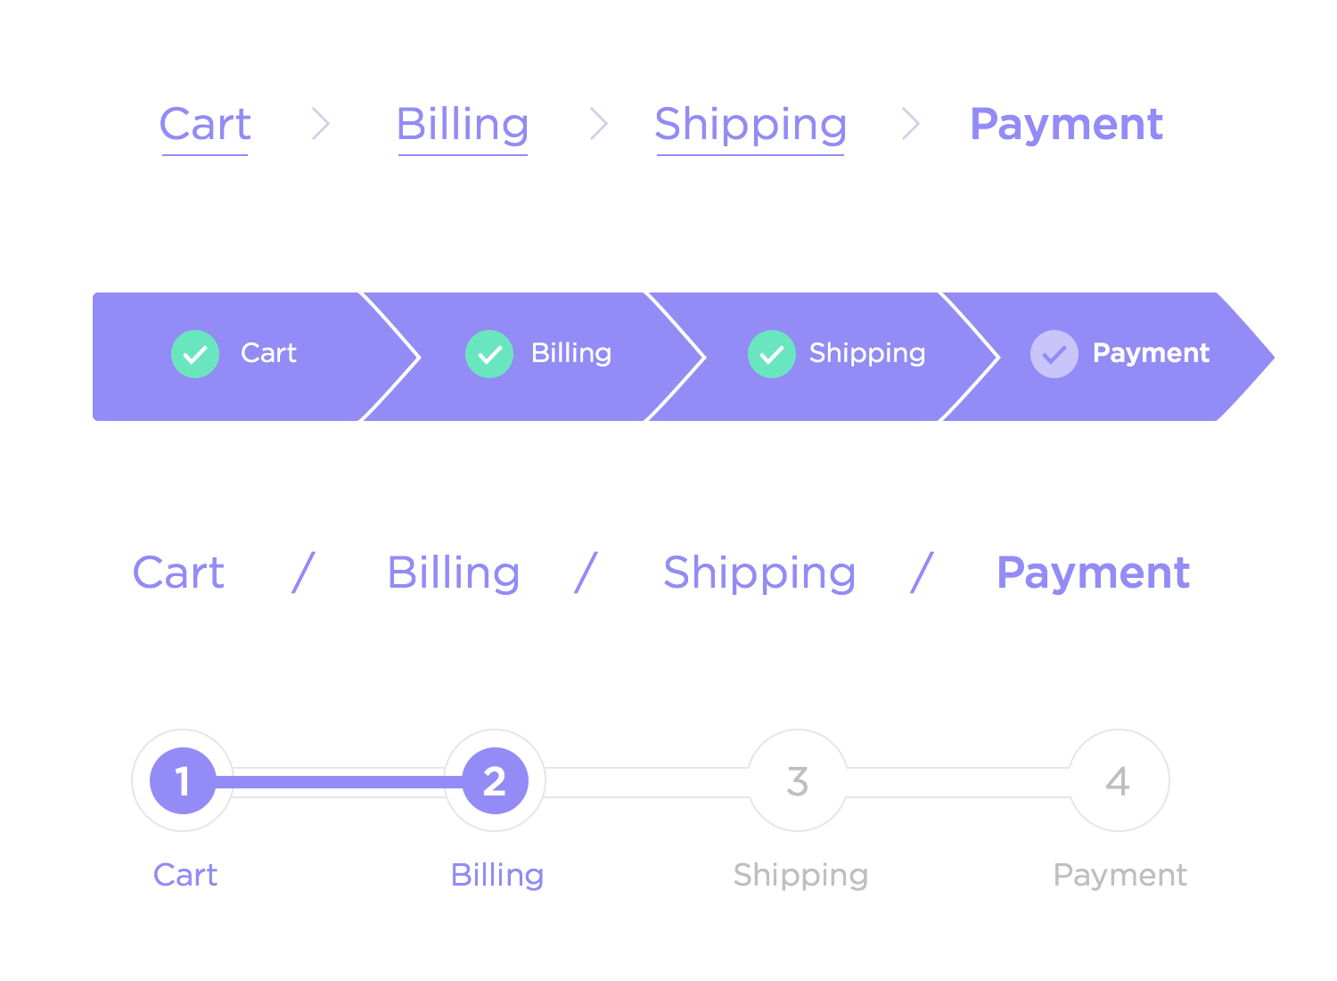.

Breadcrum informs the user about the current location within the application, so that they can identify a clickable tray.

2] **Pagination** divides the contents into allowing the user to navigate sequentially or to directly jump to the page.

3] **Search Box** : - Helps the user to navigate to the desired content

4] **Slider** :- Also known as track bars. Allows users to set or adjust a value.

5] **Hyperlinks** :- It used to navigate from one page to another.

6] **Information Component** : - Provides information

7] **Notifications** :- Used to prompt the user on various ascepts.

8] **Alert** :- It provides a warning message to the user on completion of a task.

9] **Confirm** : - It asks for the approval of the user for completion of a specific task.

**Containers** - It contains page element to a reasonable maximum width to accommodate information on user user screen.

**Accordion** - Accordions are vertically stacked list of items that shows or hide functionalities. Clicking on a label expands the section

***TYPES OF UI***

1. Graphical User Interface
2. Voice Controlled Interface
3. Gesture-Based Interface

Form Based User Interface

Used to enter data into a program or application by offering a limited selection of choices.

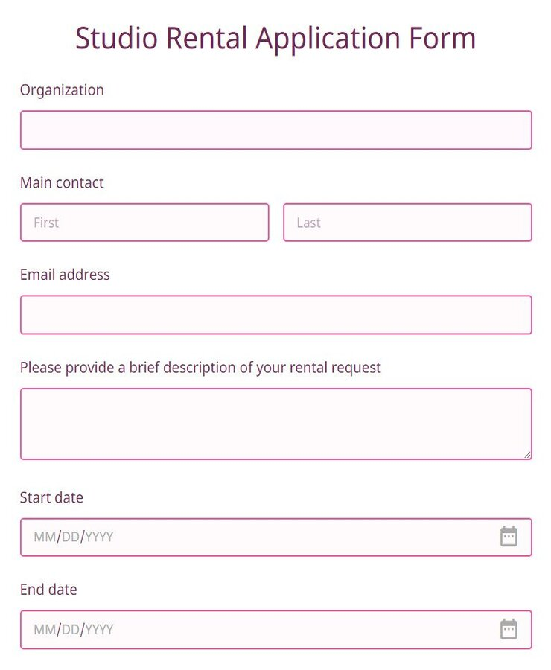

**Menu-Driven user Interface**

A UI that uses a list of choices to navigate within a program or website.

For example - Atms use menu driver UIs are easy for anyone to use

**Touch User Interface**

User interface through touch.

Most smartphones, tablets and any device that operates using a touch screen use haptic input.

**Voice User Interface**

Interactions between humans and machines using auditory commands.

Examples include virtual assistant devices, like-to-text, GPS and mu

